The Application and Development of Weather Research Forecast Chemistry (WRF/Chem) model：A Case study

¹Kuo-Cheng Lo, ^{*2}Chung-Hsuan Hung
羅國誠、洪崇軒
^{1, First Author} Department of Military Meteorology, Air Force Institute of Technology,
E-mail: u9515915@ccms.nkfust.edu.tw
^{*2,Corresponding Author} Department of Safety Health and Environmental Engineering,
National Kaohsiung First University of Science and Technology,

Abstract
The Weather Research and Forecasting (WRF) model is a new-generation mesoscale weather forecast model collaboratively developed by the meteorology research and development units of the U.S. government and the academic field. Possessing exceptional characteristics, such as favorable portability, ease of maintenance, desirable extensibility, high efficiency, and convenient operation, this model is a weather forecast model covering accuracy and convenience. The Weather Research and Forecasting / Chemistry (WRF-chem) model, incorporated with the air quality prediction model developed in WRF, possesses favorable diagnosis and prediction abilities regarding dry and wet deposition of pollutants, such as O3 and particulate matter derivatives. The purpose of this study was to introduce the WRF-chem V3.1 numerical simulation method and analyze the changing trends of pollution concentration of O3 and NOx, as well as weather types in Kaohsiung, Taiwan, during November 23, 2001. We explored the relevance of high O3 concentration and pollution to determine the air pollution situation in Kaohsiung. Based on this exploration, we can establish the Kaohsiung air quality forecast model step by step to improve the air quality in Kaohsiung, Taiwan, accordingly.

Keywords: WRF-chem, air pollution

1. Introduction

The Weather Research and Forecasting Chemistry (WRF-chem) model is a new-generation mesoscale weather forecast model and assimilation system collaboratively developed by the research and development units of the U. S. government[1] and the academic field. Because the various characteristics, such as portability, ease of maintenance, extensibility, high efficiency, and convenience of this model, research staff employs this model to conduct weather forecasts and analyses conveniently. Compared to the WRF model, the WRF-chem model is a air quality prediction model developed based on WRF and diagnoses and analyzes the relationship between weather conditions and concentration changes of pollutants[2], such as O3 and particulate matter derivatives. The WRF-chem model attains desirable diagnostic and predicting abilities. Presently, few cases use the WRF-chem model in Taiwan. Therefore, the goal of this study is to introduce the principle and related application and formation of the WRF-chem model. Simultaneously, we explain the operating method to apply the WRF-chem model to simulate the atmospheric air quality using analyses of empirical cases of typical air pollutants, such as O3 and particulate matters[3]. Recently, of the atmospheric air quality across Taiwan, the air pollution in the Kaohsiung and Pingtung air quality zone in the southern Taiwan was the worst. Although the number of days with the Pollutant Standards Index (PSI) exceeding 100 has decreased in recent years, the number of days with PSI below 100 approximately only accounted for 10% of a year. Additionally[4], according to the Environmental Protection Administration, the long-term observation results of air quality monitoring stations in Kaohsiung in recent years have shown that poor air qualities are mostly observed during the end of fall to the beginning of spring. Moreover, high O3 and particulate matter concentrations are the primary air pollutants that induce the poor air quality of this region. Stratospheric O3 can protect people from damaging by ultraviolet rays. However, high O3 concentration in the troposphere irritates human eyes and respiratory tract and affects lung functions to induce respiratory tract conditions, such as cough, tachypnea, and nose and throat irritation.
Primary weather condition factors influencing regional air pollution concentrations include the wind effect, rain and cloud influences, and the height of mixed layer[5]. Because of the importance of spatial meteorology data to the diffusion and distribution of pollutants, this study used the meteorology numerical model to conduct analysis and simulation, in the expectation to provide specific understanding regarding regional meteorological characteristics. Because the WRF-chem model is prospective in its wide application, including weather forecast, atmospheric chemistry, regional climates, and pure analogy, this model helps improve the accuracy of weather forecasting through high-resolution numerical simulation analyses regarding regions of various weather types and characteristics[6].
This study employed the WRF-chem V3.1 numerical simulation method to conduct related simulation of winds and atmospheric pollutant concentrations based on the example of days with pollution of high O3 concentration in Kaohsiung during November 23 , 2011. We explored the relevance of regional weather conditions to the generation of pollutant O3 concentration. Additionally[7], synoptic weather patterns related to the high-pressure backflows frequently seen in Taiwan and the interaction between local circulations were used to analyze characteristics of weather types of days with high O3 concentration pollution in Kaohsiung. Subsequently, we gradually established the forecast model for the air quality of Kaohsiung, which can be used as a basis to improve the air quality of Kaohsiung.

2. Model Scheme

The version of WRF–chem in thisstudy is V3.1. Its meteorological model (WRF) is non-hydrostatic,with two dynamic cores (ARW and NMM), two vertical coordinates (Eulerian height coordinate and Eulerian mass coordinate) as well as many different choices for physical parameterizations to represent processes, and is designed to be a ﬂexible, state-of-the-art, portable code that is efﬁcient in a massively parallel computing environment. The chemical part of WRF–chem treats the processes of transport (advective, convective and diffusive), wet and dry deposition, chemical transformation, emission, photolysis,aerosol chemistry and dynamics (including inorganic and organic aerosols). WRF–chem employs the ofﬁcial mass coordinate, in which the advection is fully mass and scalar conserving, ﬁve order in space, and third order in time .The gas-phase chemical mechanism in the Regional Acid Deposition Model, version 2 (RADM2), with 158 reactions among 36 species, Simulations and real-time forecasting tests have indicated that the WRF model has a good performance in all kinds of weather forecasts, and has broad application prospects. The related publications of WRF-chem model can be found in http://www.wrfmodel.org/wrfadmin/publications.php.
WRF / Chem model for simulation of emission sources cited in the database for the domestic national emissions inventory (Taiwan Emission Data System) which covers all types of pollution emissions in the total emissions database, referred to as [TEDS] (http://ivy2. epa.gov.tw/air-ei/new_main2-0.htm). Emissions inventory generally refers to national, regional or company / institution and all other activities polluting emissions, so the sources covered by the scope of which includes the area within its jurisdiction the right to all fixed and mobile pollution sources, or points, faces, lines and natural sources (including biological sources, volcanoes, sea salt spray ...) and so on. For the "emission factor" in selection, only a few domestic currently measured by establishing the "emission factor" data, the application of most of the series published by the U.S. EPA reference "Compilation of Air Pollution Emission Factors" (abbreviated AP-42) or in recent years, its entire information system implementation and various coefficients of Fire () database of emission factors; "activity intensity" requires each factory or business unit accounted actual statistics; "control factor" also need to use the factory or business Unit control equipment used in the actual data. Emission factor of the cornerstone of emission estimates, with the establishment of emission factors, which makes the worth of complex emission sources estimate the system into operational estimation procedures. For emission factors, China is currently very limited self-developed by the U.S. Environmental Protection Agency and the European Environment Agency (European Environment Agency, EEA) already invested decades respective emission factors established information systems, in order to be more common on the current international reference information, among which the United States has created more pollution emission factor category, the general domestic applications to reference the U.S. emission factor database based.

(1) Dry Wet Deposition/seavenging
The process that pollutants deposit because of gravity and captured (adsorbed or absorbed by the ground) after colliding plants or soil on the ground surface is called dry deposition. When the model considers dry deposition of a pollutant the vertically downward dry deposition flux F_{d} is represented in , where represents deposition speed and represents the pollutant concentration at height Z above the ground surface. The process that substances in the atmosphere fall to the ground is called wet deposition. In the model, wet deposition is roughly divided into two types, namely, rainout and washout. Rainout is the phenomenon in the upper cloud layer, where pollutants are absorbed by raindrops in the initial phase (e.g., nucleation) and fall with rain. Washout refers to the phenomenon that pollutants in the lower atmosphere are washed down to the ground when raindrops are falling[8].
(2)Acid Deposition
Acid deposition represents that atmospheric acid migrates to the ground surface through a precipitation (e.g., rain, fog, and snow). Acid deposition chemistry refers to the investigation of all chemical reactions related to acid during the dry or wet deposition process, including the chemical composition of a precipitation, source of acidic matters, formation mechanism, sustaining mechanism, chemical conversion, and variation and trends of precipitation composition.
(3)Photolysis
Photolysis is a crucial photochemical process in the troposphere. Various optical absorptive and diffusive matters exist in the atmosphere. These matters reduce the solar light and change the solar spectral distribution and intensity of lights in various wavelengths at the ground surface. Lights at the troposphere are mostly at wavelengths greater than 290 nm. The basic photolysis equation in the WRF-chem model is shown as follows[9]:
Where is the frequency of gas-phase photochemical reactions, primarily related to photochemical flux , absorption term , and quantum term at the wavelength .
(4)Reaction of Aerosols
Particulate matter (PM) is the umbrella term covering all types of solid and liquid particulate pollutants existing in the atmosphere. Both directly emitted primary particulate matters, including sea salt, minerals, and smoke, and secondary particulate matters, such as sulfate and nitrate produced through chemical reactions. The WRF-chem model is capable of simulating these particulate matters.
The WRF-chem model presents meticulous calculation regarding gas-phase dry and wet deposition. Simultaneously, compared with other pollution models, the WRF-chem model significantly improves removal mechanisms of gas- and particle-phase matters through related physical chemistry processes in the cloud and while raining[10].

3. Model Setup

The WRF-chem model simulation run was conducted from 00:00 (CST, China Standard Time) on 23 November, 2001 to 23:00(CST) on 23 November, in which the first 48h was at the pre-integration stage. The three nesting domains were defined using Lambert projection, which can be seen in Fig. 1. The outermost domain (domain 1) covers tile whole Taiwan and East China region, with the center point at 25。N, 125。E horizontal grids of 115 x 91, and grid spacing of 27 km; domain 2, covers the southern part of China and Taiwan island, with center point of 16。N, 121。E, 73 x 73 horizontal grids, 9 km grid spacing: domain 3 is designed to cover the Kaohsiung, whose center point is 14.5。N, 120.25。E, with horizontal grids of 31 x 31, and grid Spacing of 3 km(Fig. 1).
From tile ground level to the top pressure of 100 hPa. there are 28 vertical sigma layers to all grid meshes. The model domain settings and configuration options are shown in Table 1. The initial meteorological fields and boundary conditions are from NCEP FNL (Final) Operational Global Analysis data With 1。x 1。resolution degree grids prepared operationally every six hours(http://rda.ucar.edu/datasets/ds083.2/).
Both the anthropogenic and natural emissions are considered in this study. The parameterization scheme of Guenther et al.[11, 12] was used to take into account the biogenic emission of isoprene, terpene and other VOCs.The anthropogenic emissions’ inventories were compiled by Streets et al.[13]. The point sources and the area sources were placed in the ﬁfth layer (about 450 m high) and the bottom layer of the model, respectively. Variations of the anthropogenic emissions in a day are considered.

4. Model Simulation General Synoptic Condition

Previous literature has determined that high concentration of pollutants tends to occur from the end of fall to the beginning of spring in the Kaohsiung metropolitan area[15],thereby influencing weather patterns related to air quality in Kaohsiung, such as high pressure outflow, high-pressure backflow, and the northeast monsoon. In this case study, we simulate the sampling period during November 23, 2001, when a strong continental cold air mass induced lower temperatures across Taiwan. However, no precipitation was observed in southern Taiwan, except for the scattered precipitation in the Nanzih District in the morning of November 23. Steady weather patterns of sunny day was observed at Kaohsiung region in winter season. According to the relative humidity (RH) and accumulated precipitation simulated using the WRF model, the relative humidity in Kaohsiung tended to become below 60%, representing a dry air vertical structure that is unfavorable for wet deposition. Regarding the weather patterns during November 23, 2001(Fig. 2), northeast monsoon reached at north Taiwan region area. Because Kaohsiung was at the lee side against the northeast monsoon, air pollutants could not diffuse easily in a local atmospheric circulation structure with such a poor diffusion ability.

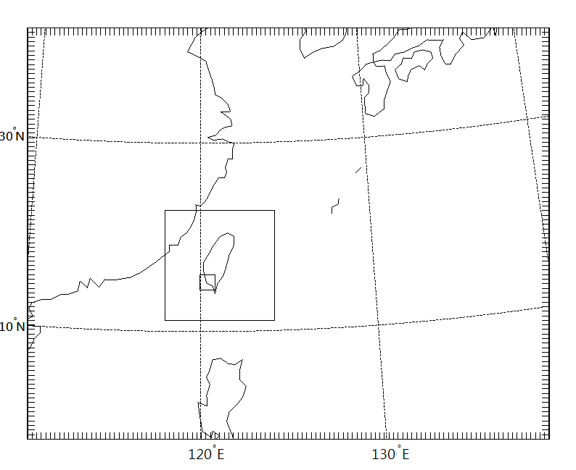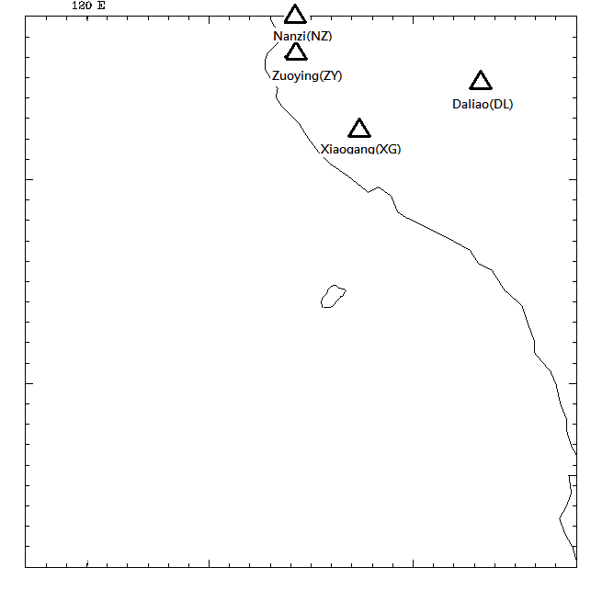

Figure 1. Nesting domain setting of the model

Table 1. WRF-chem domain setting and configuration

 | DM1 | DM2 | DM3
Horizontal grid(x,y) | 115,91 | 73,73 | 31,31
Grid spacing | 27km | 9km | 3km
Meteorological time step | 180s | 60s | 20s
Chemical time step | 180s | 60s | 60s
Microphysics | WSM3-class simple ice scheme
Chemistry option | RADM2
Dry deposition | Wesley,1989
Photolysis option | Madronich,1987
Long wave radiation | RRTM
Short wave radiation | GODDARD
Aerosol option | MADE/SorGAM

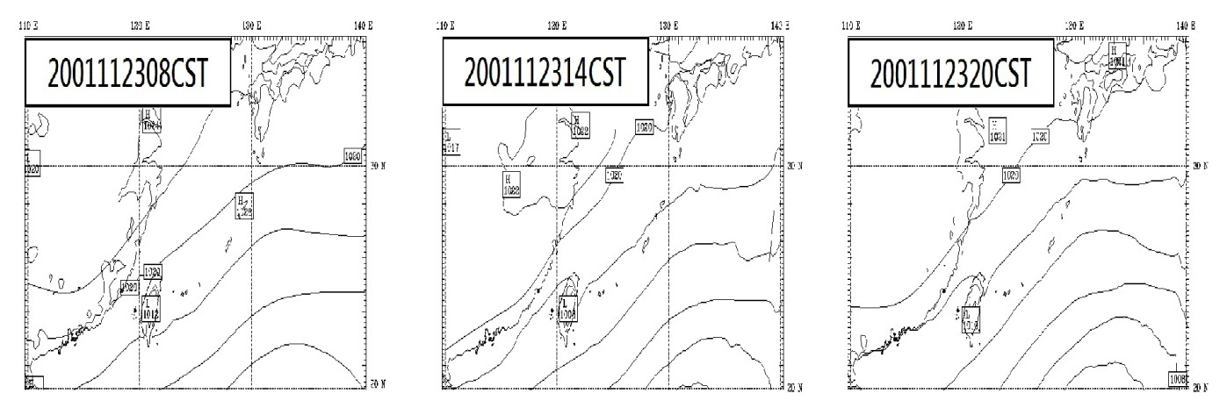

Figure 2. Weather chart for 24 November 2001 (Daily diurnal)
5. Model Simulation Results of Ozone Episode

Taiwan was covered by high pressure backflow in November 23, 2001 such as higher temperature than other region of Taiwan, low humidity, strong solar radiation and southwestly or Westerly airﬂow at afternoon in winter, also have signiﬁcant inﬂuence on the formation of this continuous heavy photochemical pollution episode. The O₃ concentration was affected by the nonlinearity of NO_{x} and VOC. Under the local or instantaneous diffusion condition, the model simulated ozone precursors NO_{x} and conducted initial comparison with the real data of weather stations of the Environmental Protection Bureau. Both simulation and real measurements showed higher concentration distribution of pollutants. This indicated that higher concentration responses of precursors influenced the O₃ concentration and could be used as an important reference for controlling NO_{x} and VOC emissions to effectively reduce O₃ pollution. The wind field shows that southwestly or westerly airflow was dominated in the Kaohsiung regions, It was considered that the simulation results well reproduced the ozone photochemistry and the regional scale ozone episode over the Kaohsiung region(Fig. 3 ).

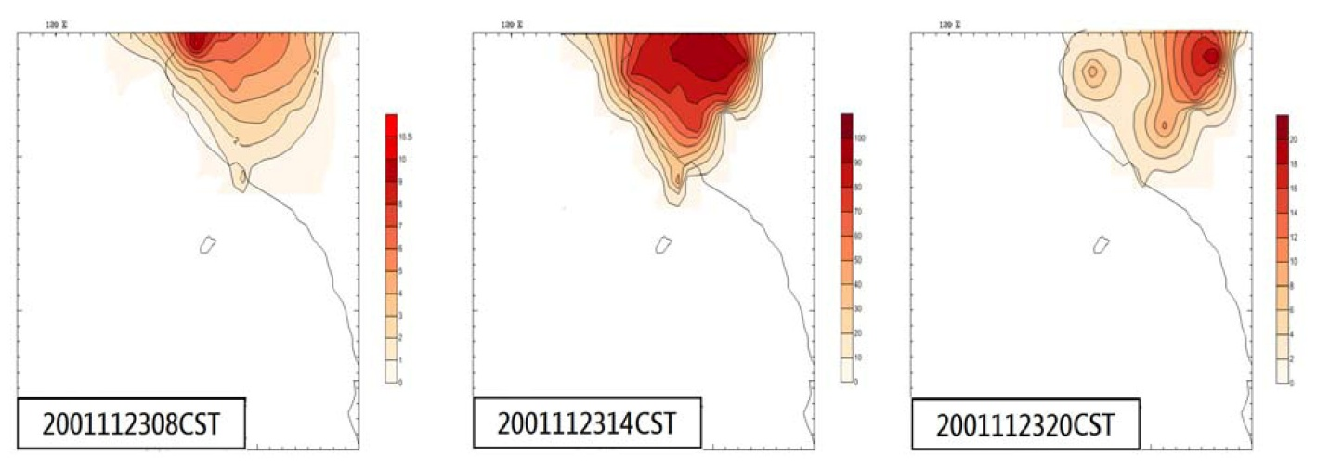
Figure 3. The simulated distribution of surface ozone concentration averaged at 15:00(CST) 23 November 2001(ppb)

Fig. 4 shows the time series of the observed and modeled ozone and NO_{x} concentrations results. The peak ozone of the day observed in Nanzi(NZ), Zuoying (ZY),Daliao(DL) and Xiaogang (XG) stations (their locations , are illustrated in Fig. 1) of Taiwan Kaohsiung city . Fig. 3, which is tile composite image from the modeling results of three domains, illustrates the spalial distribution of surface O₃ concentration averaged from 00:00 (CST) 23 to 23:00(CST) 23 November,2001 during the episode. The simulations and observations show reasonable agreement at each site, Both simulated and observed O₃ concentrations have displayed significant daily variation, showing the highest Concentrations about 15:00(CST) and lower concentrations at night.The high O₃ concentration zones are mainly in the east and west Kaohsiung as well as the Zuoying (ZY), Daliao(DL) regions, located at the urban center with high density population and high-traffic motor vehicles with O₃ maximum of 116 ppb. It is remarkable that the average O₃ concentration Zuoying (ZY), Daliao(DL) regions is much higher than that on the land in the other areas. Due to tile longer life time of O₃ (Daily diurnal) in the troposphere, the distribution of O₃ concentration is greatly influenced by airflow.
The observed surface O₃ concentrations at Nanzi(NZ), Zuoying(ZY), Daliao (DL) and Xiaogang (XG) stations in Kaohsiung region . It is obvious that O₃ is net produced at day and net lost at night. The production rate reaches its maximum at about 15:00(CST), showing that the atmospheric chemical reactions are relatively strong at afternoon, while the greatest loss occurred at about 20:00. On the heavy-pollution episode days 23 November, 2001 the production and loss of O₃ are much more signiﬁcant, with rates of 116.7 ppb (at 15:00(CST) on 23 November) and 1.6 ppb (at 23:00(CST) on 23 November) in Daliao (DL) station, respectively. Due to the sufﬁcient O₃ precursors and the advantaged weather conditions, O₃ can be strongly generated and consumed.
The four stations ozone concentration absolute errors (model minus observation) in Kaohsiung region are much smaller than NO_{x} concentration, with 39.2 ppb in Daliao (DL) station; it is important than other stations, for example, 36.0 ppb in Zuoying (ZY), 42.2 ppb in Nanzi(NZ), and 31.5 ppb in Xiaogang (XG). These indicate that the local emissions may have strong inﬂuence on O₃ level in Kaohsiung region. To improve O₃ modeling, a good emission inventory of O₃ precursors is necessary.
Though some O₃ peaks are underestimated, for example, it does not well simulate the high O₃ peak on 23 Noveember at Zuoying (ZY) and Daliao (DL) station. But the O₃ concentration peaks both at Nanzi(NZ) and Xiaogang (XG) have well simulate (Fig. 4 left side), The highest correlation coefficient of O₃ concentrations(model minus observation) is found to be 0.89 at Daliao (DL)station ,followed by 0.87 for Xiaogang (XG) station 0.86 for Zuoying(ZY) station and 0.84 for Nanzi(NZ) station.on the whole, they are overestimated. The simulated average O₃ levels are basically lower than the observations station in Kaohsiung region.
Since O₃ is formed by a series of complex reactions between NO_{x} and VOCs, O₃ concentrations are closely related to the levels of its precursors NO_{x} and VOCs. Due to no VOC observation during the episode[14], only NO_{x} concentrations between the model and the observation were compared. The model results at the four air quality monitoring stations. The highest correlation coefficient of NO_{x} concentrations(model minus observation) is found to be 0.83 at Daliao (DL) station, followed by 0.8 for Xiaogang (XG) station 0.7 for Zuoying(ZY) station, and 0.65 for Nanzi(NZ). To improve NO_{x} modeling, the concentrated observation radiation intensity data and well modeling radiation scheme is necessary.In general, most simulated NO_{x} levels are underestimated at four stations in Kaohsiung region, these may be attributed to the underestimation of NO_{x} emission and the coarse resolution of emission inventory.
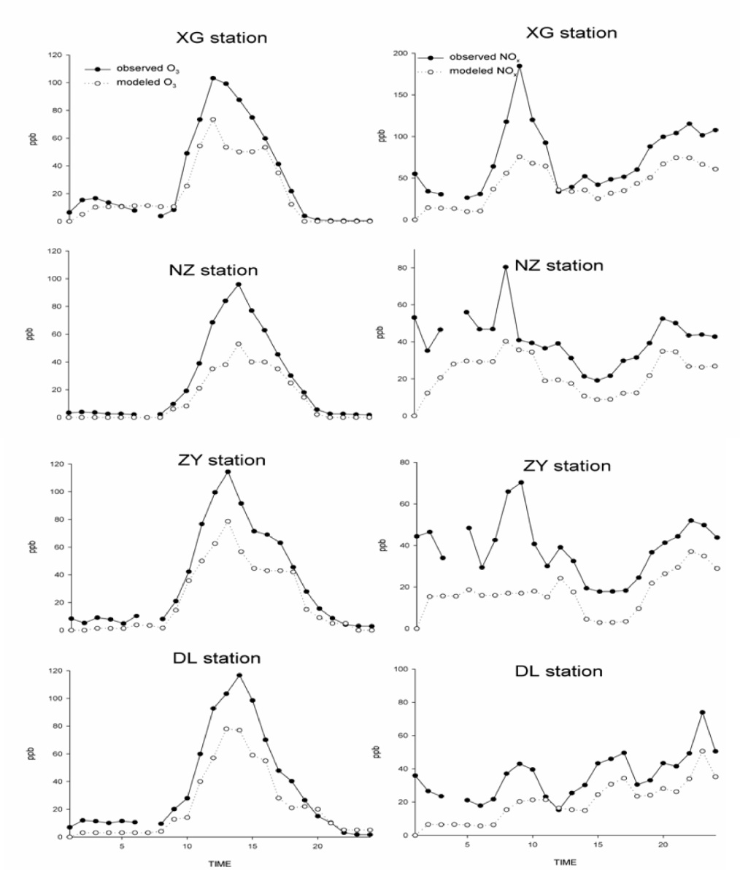

Figure 4. The Daily diurnal of simulated vs observed (a)ozone(Left) and (b)NOx (Right)concentrations at four selected sites in Kaohsiung during 00:00(CST)23 to 23:00 23 November.(The locations of DL,ZY,NZ,XG air quality stations)

The observed surface NO_{x} concentrations at Nanzi(NZ), Zuoying(ZY), Daliao (DL) and Xiaogang (XG) stations in Kaohsiung region . It is obvious that NO_{x} is net produced at day and net lost at early morning. The production rate reaches its maximum 184.6ppb at Xiaogang (XG) about 09:00(CST), while the greatest loss occurred at about 02:00(CST). On the heavy-pollution episode days 23 November, 2001 the production and loss of NO_{x} are much more signiﬁcant, with rates of 184.6 ppb(at 09:00(CST) on 23 November and 17.8 ppb (at 16:00(CST) on 23 November) in Zuoying(ZY) station, respectively. Due to the sufﬁcient NO_{x} precursors and the advantaged weather conditions, NO_{x} can be strongly generated and consumed.The NO_{x} concentration absolute errors (model minus observation) at four stations are much larger, with 45.3 ppb in Zuoying (ZY) station.

6. Conclusion

By using the generation of regional air quality model WRF–chem V3.1, a daily heavy-pollution episode in the Taiwan Kaohsiung region within 23 November, 2001 was investigated. The main results and conclusions are summarized as following.The development of this episode was high-pressure backflow in Kaohsiung region.When the high concentrations ozone and No_{x} pollution occurred, was at the high-pressure backflow system moving approach Kaohsiung region. such as more higher temperature than other region of Taiwan, low humidity,strong solar radiation and Southwestly or Westerly airﬂow at afternoon in winter, also have signiﬁcant inﬂuence on the formation of this continuous heavy photochemical pollution episode.The ozone emissions in four observed stations of Kaohsiung region were successfully modeled. The difference between simulation and real emission should probably be relatively larger due to the negligence of traffic sources. The emissions concentration show that significant NO_{x} concentration difference exists between simulations and observed at four stations(Nanzi(NZ), Zuoying (ZY),Daliao(DL) and Xiaogang (XG))especially in higher concentration distribution.
Therefore, biogenic emissions arc important for air quality modeling. In Kaohsiung region, the maximum impact of ozone emissions on formation is 21- 27 ppb when maximum ozone values are of the order of 90-120 ppb.The geographical distribution of the biogenic impact was shown to depend mainly on NO_{x} emissions. The Kaohsiung region and the Guangdong province were the areas that have highest response to biogenic impact. The Kaohsiung region was the origin area of biogenic impact in Kaohsiung region and the additional ozone buildup due to biogenic impact could he transported to other places in Kaohsiung region.
WRF–chem has shown relatively good performance in modeling of this continuous higher pollution episode, the simulated and the observed O₃ concentrations are basically in agreement at each site. Therefore, it can be served as a powerful tool for air quality prediction in the future.
Finally in this study, we briefly introduce the characteristics and chemical mechanisms of the WRF/CHEM model and use principles related to this model to conduct primary simulation analysis of pollutants in Kaohsiung. The following relevant characteristics and applications are organized in the conclusion of this study.
1. Computer system requirements and compatibility
Because the WRF-chem model is highly compatible to all types and levels of computers, including personal computer, cluster computer, and super computer, this model is suitable for analysis and application regarding general pollution forecast and diagnosis operation system levels.
2. Preprocessing of weather diagnosis and forecast data
Because the WRF model is a weather diagnosis and forecast model, its simulation related to weather is more extensive and professional, compared to the partial considerations of other diffusion models.
3. Ability to simulate diverse chemical and plume diffusion
In addition to being able to simulate the diffusion process of photochemical smog, such as O₃ and particulate matter derivatives, the WRF-chem model also uses extensive chemical diffusion equations regarding pollutants of sulfide, nitride, and acid, dry, and wet deposition as the background of simulation.
The WRF-chem model will be prospective in its extensive applications, such as weather forecasting, atmospheric chemistry, and regional climates. This model can also analyze traces of pollutant diffusion and periodically forecast and diagnose contribution levels of various sources of pollution to pollutant concentration distributions at simulated regions and detection stations.

7. Acknowledgments

The authors would like to express their appreciation to NCAR for releasing and updating the WRF-chem model.NCEP/NCAR reanalysis data were obtained from NOAA CDC of this work.The meteorological and air quality observation stations data were supplied by the Environmental Protection Administration,(R.O.C.Taiwan) Special Kaohsiung Region(http://taqm.epa.gov.tw/taqm/zh-tw/YearlyDataDownload.aspx).

8. References
- Žabkar, R., Rakovec, J., Koračin, D., “The roles of regional accumulation and advection of ozone during high ozone episodes in Slovenia:A WRF/Chem modeling study”, Atmosphere Environment, vol. 45, no. 1, pp.1192-1202, 2011.
- Forkel, R., Werhahn, J., Hansen, A. B., McKeen, S., Peckham, S., Grell, G., Suppan, P., “Effect of aerosol-radiation feedback on regional air quality-A case study with WRF/Chem”, Atmosphere Environment, vol. 53, no. 1, pp.202-211, 2012.
- Chan, L. Y., Chan, C. Y., Qin, Y., “Surface ozone pattern in Hong Kong”, Journal of Applied Meteorology, vol. 37, no. 10, pp.1153-1165, 1998.
- Lee, J. Y., Kim, Y. K., Kim, H. K., Choi, K. C., Kim, H., Jo. H. G., “Monitoring Service for Providing The Air Pollutant Degree Using Mobile Virtual Environment”, International Journal of Networked Computing and Advanced Information Management, vol. 2, no. 1, pp.22-26, 2012.
- Wei, X. L., Li, Y. S., Lam, K. S., Wang, A. Y., Wang, T. J., “Impact of biogenic VOC emissions on a tropical cyclone-related ozone episode in the Pearl River Delta region, China”, Atmosphere Environment, vol. 47, no. 1, pp.7851-7864, 2007.
- Christian, R. A., Lad, R. K., Deshpande, A. W., Desai, N. G., “Fuzzy MCDM approach for addressing composite index of water and air pollution potential of industries”, International Journal of Digital Content Technology and its Applications, vol. 2, no. 2, pp.64-71, 2008.
- Li, H. G., Wu, H., Gao, B. J., “The Optimized Evaluation Model of Atmosphere Quality based on Improved Hybrid Accelerating Genetic Algorithm”, International Journal of Digital Content Technology and its Applications, vol. 5, no. 6, pp.267- 274, 2011.
- Peckham, S. E., Grell, G. A., Mckeen, S. A. Ahmadov, R., Barth, M., Pfister, G., Wiedinmyer, C., Fast, J. D., Gustafson, W. I., Ghan, S. J., Zaveri, R., Easter, R. C., Barnard, J., Chapman, E., Hewson, M., Schmitz, R., Salzmann, M., Beck, V., Freitas, S. R., “WRF/Chem Version 3.4 User’s Guide, NOAA Earth System Research laboratory”, National Center for Atmosphere Research, Boulder Colorado, USA, 2012.
- Jiang, F., Wang, T., Wang, T., Xie, M., Zhao, H., “Numerical modeling of a continuous photochemical pollution episode in Hong Kong using WRF-chem”, Atmosphere Environment, vol. 42, no. 1, pp.8717-8727, 2008.
- Yerramilli, A., Dodla, V. B., Desamsetti, S., Challa, S. V., Young , J. H., Patrick, C., Baham, J. M., Hughes, R. L., Yerramilli, S., Tuluri, F., Hardy, M. G., Swanier, S. J. ,“Air Quality Modeling for the Urban Jackson, Mississippi Region Using a High Resolution WRF/Chem Model”, International Journal of Environmental Research and Public Health, vol. 8, no. 6, pp.2470-2490, 2011.
- Guenther A. B., Zimmerman P. R., Harley P. C., Monson R. K., Fall R., “Isoprene and monoterpene emission rate variability: model evaluations and sensitivity analyses”, Journal of Geophysical Research, vol. 98, no. 1, pp.12609-12617, 1993.
- Guenther, A., Zimmerman, P., Wildermuth, M., “Natural volatile organic compound emission rate estimates for US woodland landscapes”, Atmospheric Environment, vol. 28, no. 1, pp.1197-1210, 1994.
- Streets, D. G., Bond, T. C., Carmichael, G. R., Fernandes, S. D., Fu, Q., He, D., Klimont, Z., Nelson, S. M., Tsai, N. Y., Wang, M. Q., Woo, J. H., Yarber, K. F., “An inventory of gaseous and primary aerosol emissions in Asiain the year 2000”, Journal of Geophysical Research, vol.108, no. D21, pp. 8809-8831, 2003.
- Wang, Y. X., McElroy, M., Wang, T., Palmer, P., “Asian emission of CO and NOx: constraints from aircraft and Chinese station data”, Journal of Geophysical Research Atmosphere, vol. 109, no. 10, pp. 1-26, 2004.

